RISE KVS
REGISTRATION
PROCESS


Go to kvtt.cograd.in . Click on Register now
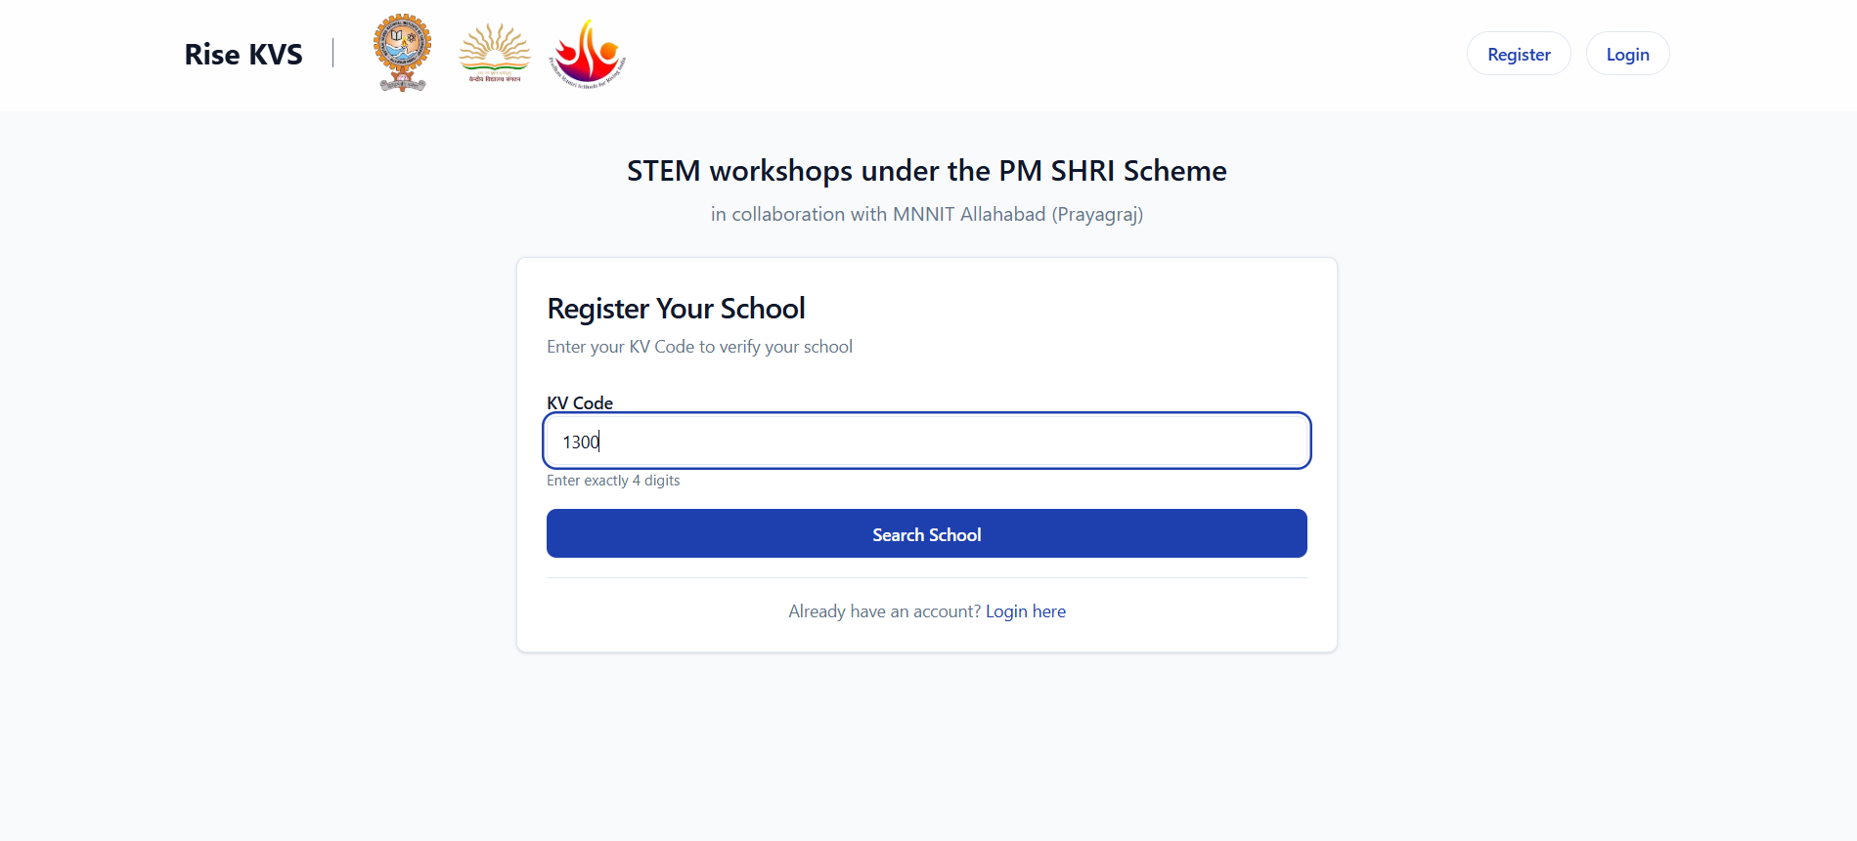 You will come across Register Your School page, just enter your KV code
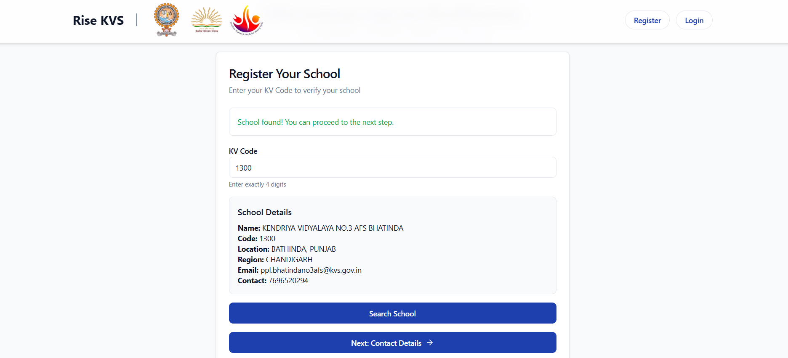When you fill in the KV code, it will fetch all the other KV information itself.
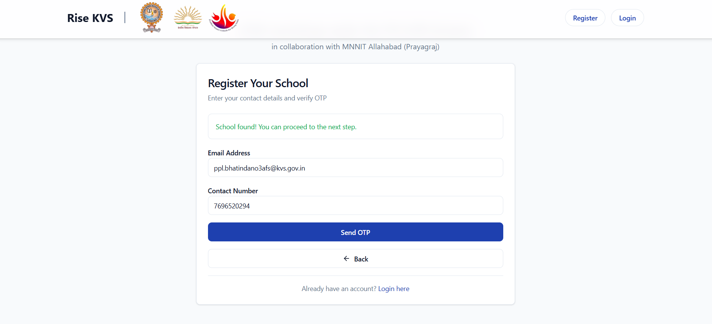Now you will be asked to enter your schools contact details.
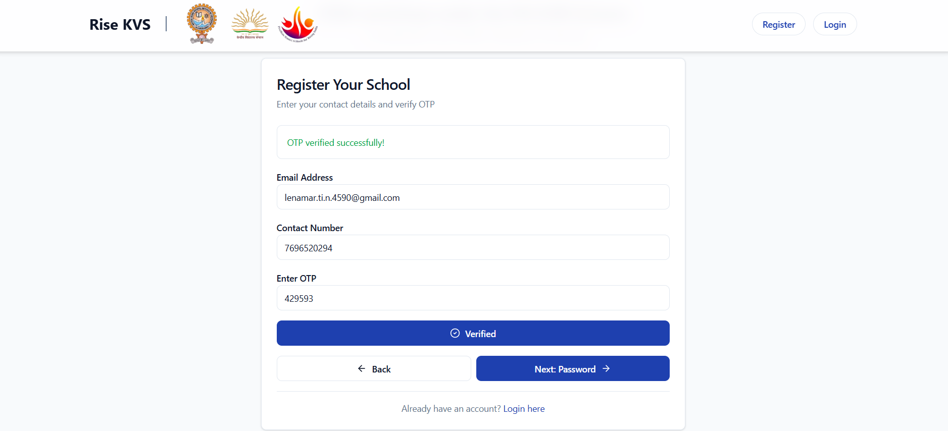
Note: It will automatically fetch KV contact number and email. If required you can fill your own contact no. and mail.
Click on send OTP, you will receive the OTP on the email address you have entered.
Fill in the OTP and click on verify.
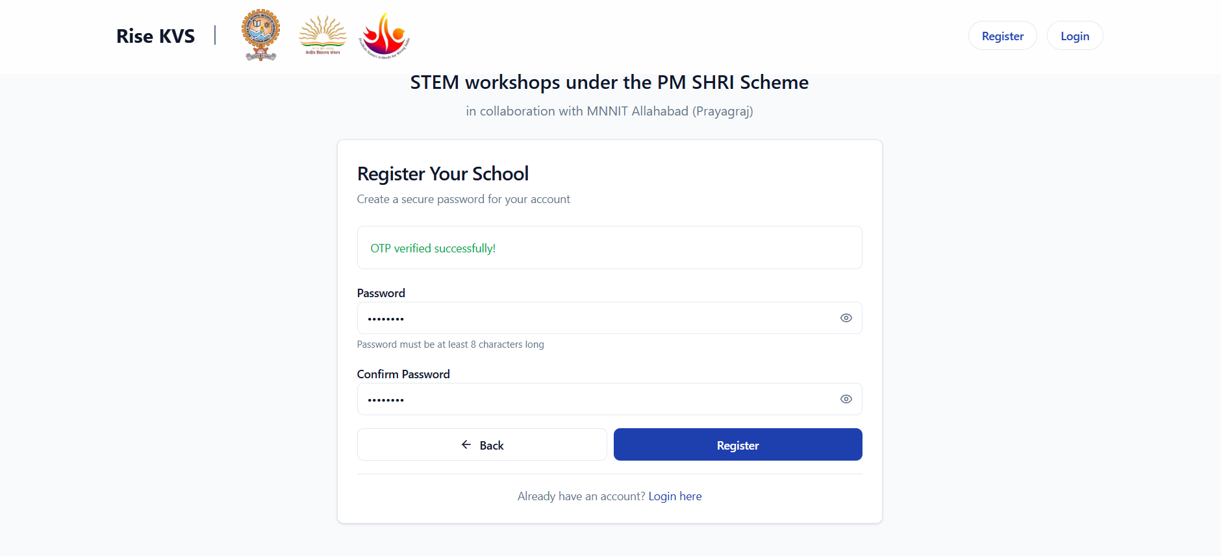
Set up a password atleast 8 characters long.
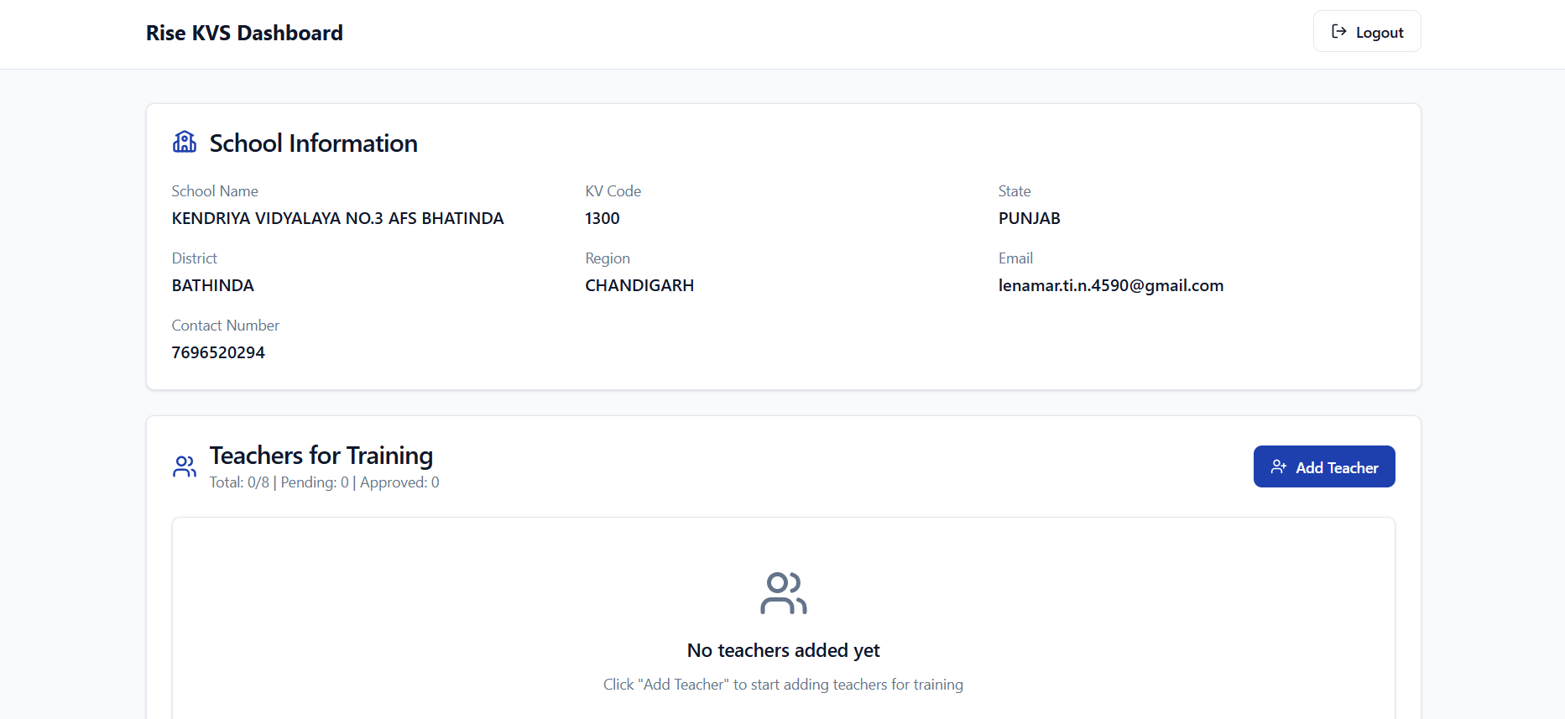
Now you will be redirected to Rise KVS Dashboard.
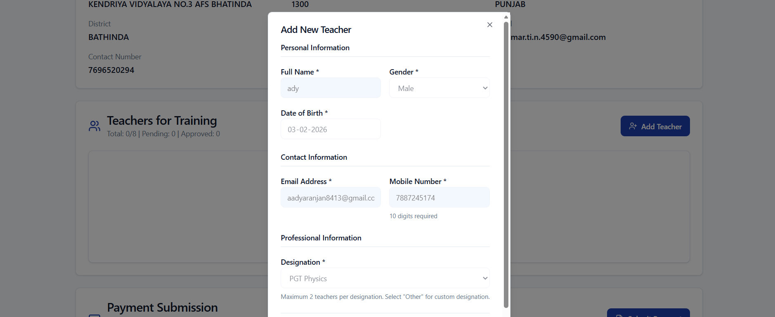Guideline to add Teacher
Click on Add Teacher and add in teacher details, maximum of 8 can be added.
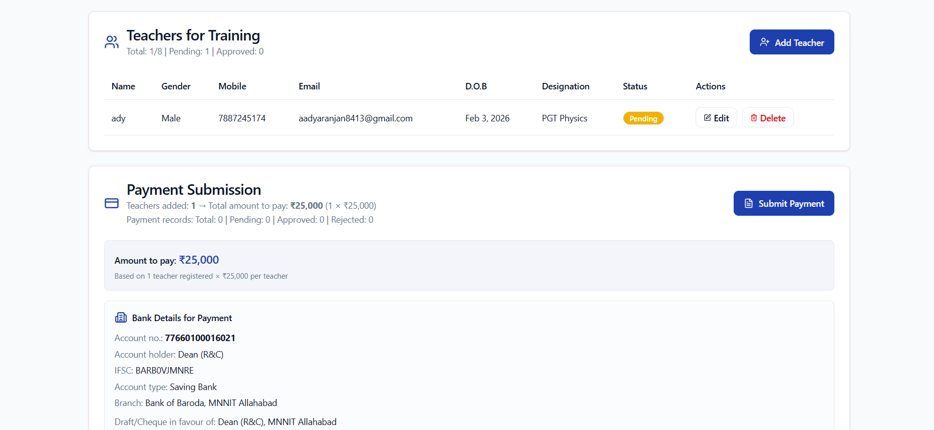
The teacher will now be added to the Teachers for Training tab.

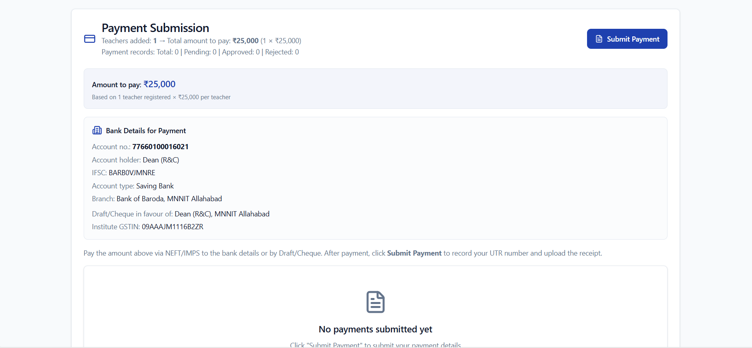 Now there are bank details mentioned on the page itself, Pay the amount on the given bank details. The payment amount is adjusted according to the no. of teachers added.
After payment completion, click on Submit Payment
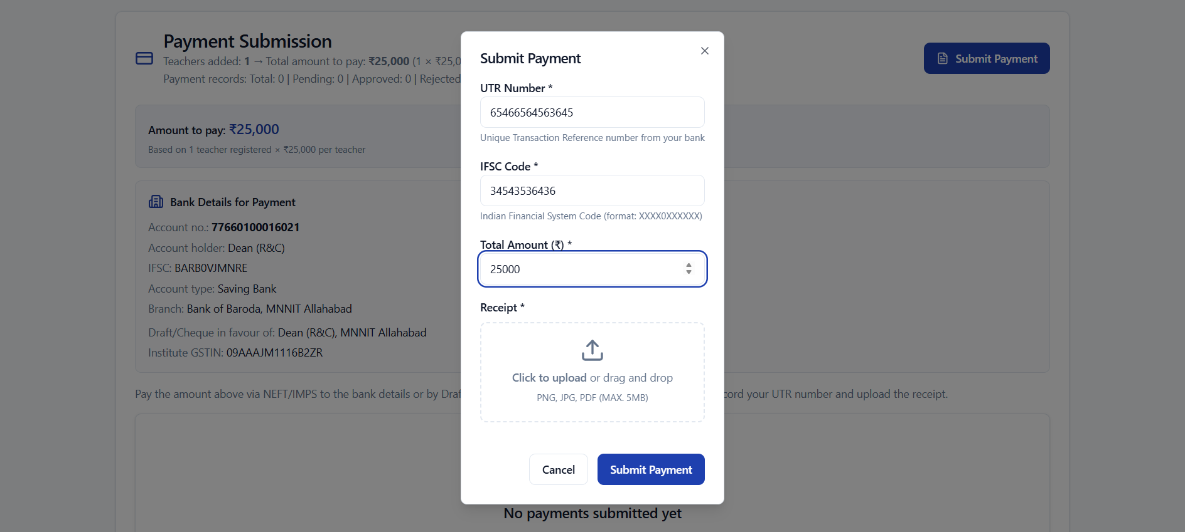
The payment made to the bank will generate a UTR No. Add the transaction details to the Submit Payment tab along with a image of the receipt.
After your payment and information is verified the Teacher for training status will change to Approved

